Emotion strategy cards

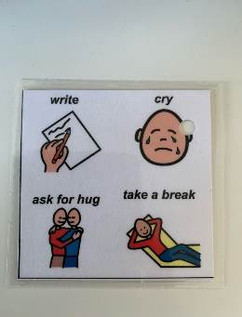


You can support the child to:
- Understand and use a range of emotion words.
- Respond to strategies/help offered by others.
- Use language to request help or a break.
- Use appropriate behaviour strategies modelled by adults (e.g., deep breaths, going for a walk).
- Use more complex strategies (e.g., writing a list of what I need to do).
- Discuss how to cope in future situations (e.g., asking to remain in class to avoid the sound of the school bell in the corridor).

As the adult you can:
- Respond to signals and interpret behaviours as communication or linked to a sensory need, e.g., why is the child running around? Do they need to move to help regulate their emotions?
- Recognise emotional needs and provide support for emotional regulation. Verbalise how they are feeling and show a picture if needed.
- Model appropriate coping strategies, e.g., stretching, getting a drink.
- Use visual supports, e.g., pictures of appropriate activities to choose to calm down.

